KS3 Landscape Change: Lower River Otter
- The maps below show the location of the River Otter and its drainage basin.

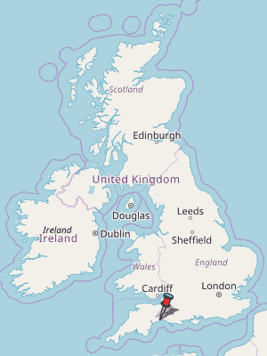
N
N

150km
Location of the River Otter

10km

River Otter Drainage Basin

(a) Describe the location of the River Otter in the UK.
----------------------------------------------------------------------------------------------------------------------------------------------------------------------------------------------------------------------------------------------------------------------------
(b) Use a circle to identify and label the most northerly source of the River Otter.
(c) Locate and label the Blackdown Hills
(d) Locate and label a tributary and a confluence.
(e) Write three facts about the River Otter.

• ----------------------------------------------------------------------------------------------------------------
• ----------------------------------------------------------------------------------------------------------------
• ----------------------------------------------------------------------------------------------------------------

- The map below is an Ordnance Survey (OS) 1:25,000 map of the Lower Otter.
- Locate and label the following:
- the River Otter
- the river’s floodplain
- the pebble ridge (bar)
- the mouth of the river
- a drainage ditch
- an embankment
- gently rolling hills

1 km
N

- Using evidence from the map, suggest why the River Otter is popular with visitors.
----------------------------------------------------------------------------------------------------------------------------------------------------------------------------------------------------------------------------------------------------------------------------------------------

- The oblique aerial photo below shows the landscape of the Lower Otter.

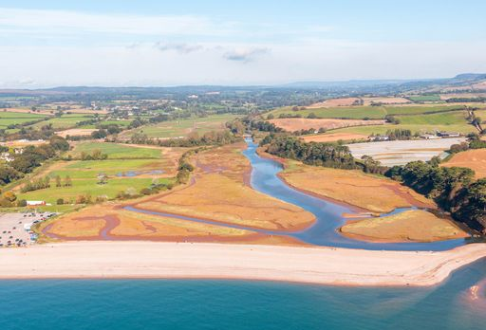
Saltmarsh in the river estuary
Car park
Wide, flat floodplain
Woodland
Gently rolling hills
Broad pebble ridge
Embankment
Farmland

- In what direction is the photo looking? _____________
- Draw arrows to locate the text boxes on the photo.
- Use the information in the text boxes and your own observations to describe the landscape of the Lower Otter using no more than 50 words.
--------------------------------------------------------------------------------------------------------------------------------------------------------------------------------------------------------------------------------------------------------------------------------------------------------------------------------------------------------------------------------------------------------------------------------------------------------------------------------------------------------------------------------------------------------
- Suggest how the following factors can cause landscape change in the photo.

Coastal (sea) processes

River processes

Weather and climate

Human activities

- This photo shows the effects of coastal processes on the landscape at the mouth of the River Otter.
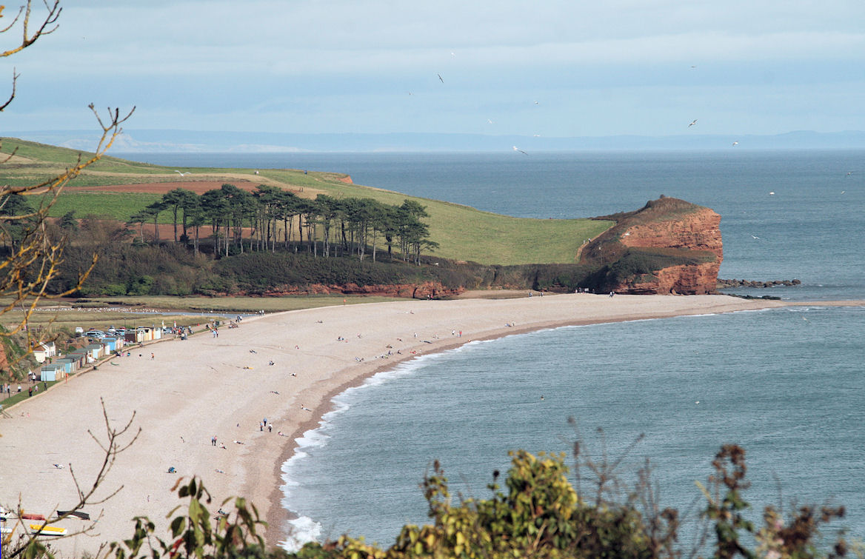

- In what direction is the photo looking? ___________
- Locate and label the pebble ridge (bar), the sandstone cliff and the wave cut platform.
- Use a series of arrows to indicate how pebbles are moved across the beach from west to east.
- In the box below, draw your own diagram to describe the formation of a cliff and wave cut platform.

- Flooding is common in the Lower Otter. In the photo below, the embankment – constructed to protect the land from flooding – was overtopped after heavy rain to create a shallow lake.
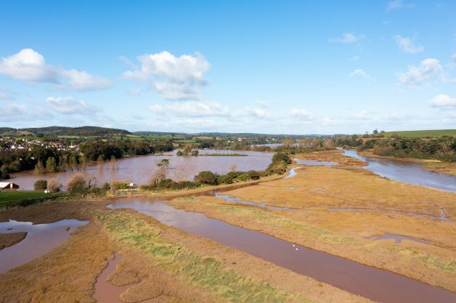
As the diagrams below show, regular flooding leads to the deposition of sediment and contributes to the formation of the river floodplain.
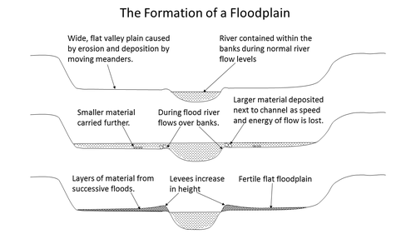
https://timeforgeography.co.uk/more/blog/formation-floodplain/
- Using a blue colour, shade the areas of water in the diagrams.
- Using a brown colour, shade the layers of sediment deposited by flooding.
- Explain how flooding leads to landscape change in a river valley.

--------------------------------------------------------------------------------------------------------------------------------------------------------------------------------------------------------------------------------------------------------------------------------------------------------------------------------------------------------------------------------------------------------------------------------------------------------------

- Weather and climate affect landscape change.
- Define the terms ‘weather’ and ‘climate’.
Weather

Climate

- Climate change is expected to have the following effects on the Lower Otter:
- Rise in sea level by up to 1m by 2100
- Increased storminess with higher and more powerful waves
- Increased intensity of rainfall events
The photo below shows the landscape at the mouth of the River Otter.
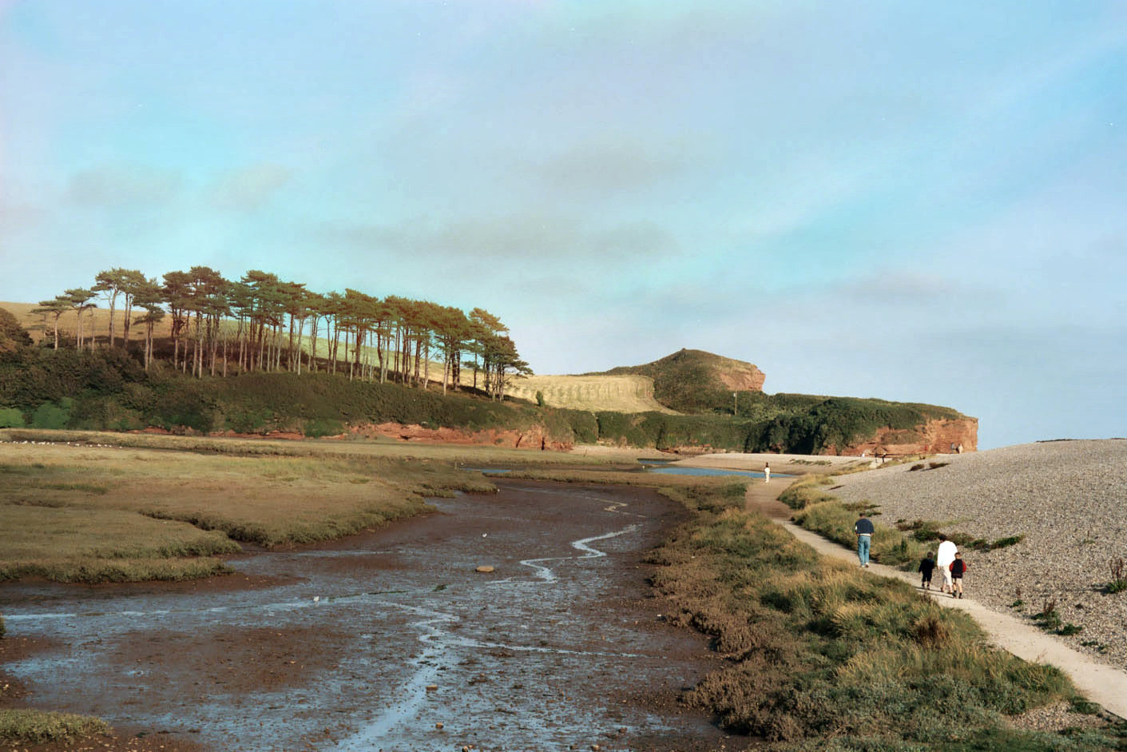

- Describe how climate change may affect the landscape shown in the photo.

----------------------------------------------------------------------------------------------------------------------------------------------------------------------------------------------------------------------------------------------------------------------------------------------------------------------------------------------------------------------------------------------------------------------------------------------------------------------------------------------------------------------------------------------------------------------------------------------------------------------------------------------------------------------------------------------

- The landscape of the Lower Otter has changed a great deal particularly since the construction of embankments about 200 years ago. The sketches below show the area past and present, before and after the embankments were constructed.
Spot the difference!
- Using a pencil, draw circles to identify landscape changes resulting from the construction of the embankment.
- Consider the advantages and disadvantages associated with the landscape changes you have identified.
Advantages | Disadvantages
- The embankments are in need of repair. In response to the threats posed by climate change it has been decided that the long-term sustainable management of the Lower Otter should involve restoring the landscape to a more natural state.
- On the map, locate and label the car park. Look back to the photo in Activity 3 to help you.
- Suggest why visitors may be attracted to the restored Lower Otter estuary.
------------------------------------------------------------------------------------------------------------------------------------------------------------------------------------------------------------------------------------------------------------------------------------------------------------------------------------------------------------------------------------------------------------------------------------------------
- Describe how the breaching of the embankments will change the landscape of the Lower Otter.
-------------------------------------------------------------------------------------------------------------------------------------------------------------------------------------------------------------------------------------------------------------------------------------------------------------------------------------------------------------------------------------------------------------------------------------------------------------------------------------------------------------------------------------------------------------------------------------------------------------------------------------------------------------------------------------------------------------------------------------------------------------------------
- The photo below is a present day panoramic ground photo looking across the Lower Otter towards the south-east. Below the photo is an artist’s sketch of the same view in 2038 (summer) some 15 years after the breaching of the embankments.

The artist’s sketch is to be used as an information board to show people what the landscape may look like in the future. You have been asked to add a selection of labels to help interpret the changes and suggest some benefits for people and wildlife. Locate and write your suggested labels on the copy below.

Map skills Activity

- Locate the Otter Estuary Nature Reserve in grid square 0782. What symbol is used to indicate that this is a nature reserve? __________________ (blue duck)
- What is the map evidence that the land in the Otter Estuary Nature Reserve is saltmarsh? ______________ (blue saltmarsh symbol)
- Give the six-figure grid reference of the car park. _____________ (073820)
- Measure the length of the pebble ridge from the car park to its easterly tip. Give your answer to the nearest 100 metres. ___________ (400m)
- What is the name of the coastal footpath? ____________________ (South West Coast Path)
- Otterton Ledge (grid square 0781) is an example of what coastal landform? ____________________________ (wave-cut platform)
- What type of woodland is located at the northern end of grid square 0782? _________________ (coniferous)
- Locate the many drainage ditches in the Lower Otter. What is the evidence that these are artificial rather than natural channels? ___________________ (straight channels)
- What is the map evidence that the land either side of the River Otter floodplain is hilly? _______________________________________________________________________ (large number of quite closely spaced contours)
- What is the highest spot height on the map extract? Give its grid reference. __________________ (62m 089833)
- Locate the River Otter’s floodplain in grid square 0783.
- Measure the width of the floodplain. Give your answer to the nearest 100 metres. _________ (300m)
- What is the evidence that the floodplain is flat? _____________ (no contours)

N
86
06
09
08
07
85
84
83
82
I km

'With kind permission and contains Ordnance Survey data'

