GCSE Managed coastal realignment: Lower River Otter Map Skills (1:25,000)

Part A: Introduction
The River Otter flows for a distance of about 44km (27 miles) from its source in the Blackdown Hills (Somerset) to its mouth in the England Channel at Budleigh Salterton (Devon).
Map A is a 1:25,000 OS map extract that shows the course of the River Otter as it flows southwards from the village of Otterton to join the sea. This is the Lower Otter.
Photo B is an oblique aerial photo of the Lower Otter looking towards the sea. The outskirts of Budleigh Salterton are towards the top right of the photo.
- Study Map A and Photo B.
- In what direction is the photo looking? ___________
- What is the land use at X? ______________________
- Using Map A, locate and label the Otter Estuary Nature Reserve on Photo B.
- Using Map A and Photo B, describe the vegetation in the nature reserve.
----------------------------------------------------------------------------------------------------------------------------------------------------------------------------------------------------------------------------------------------------------------------------
- What is the land at Y used for? __________________
- What symbol is used to show the flood embankment at Z?
- What is the name of the long distance footpath that follows the top of the embankment shown in Photo B? ____________________________
- Locate gridline 83. Measure the width of the floodplain (between the 5m contours either side of the valley). Give your answer to the nearest 100 metres.
_____ cm on the map
_____ m on the ground

Photo B Aerial photo of the Lower River Otter
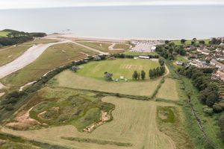
Y
X

Map A OS 1:25,000 map of the Lower River Otter
N
'With kind permission and contains Ordnance Survey data'.
I km

Part B: Flood hazard
The River Otter floods most winters after periods of heavy rain. Fields are flooded and some roads become impassable causing properties, and even whole villages such as Otterton, to be cut off. Photo C shows the extent of flooding in 2018. This photo was taken from the beach looking north.
Look closely at Map A to trace the full extent of the embankments. They can be identified easily on the map by the broken green lines (two footpaths run along the top of the embankments). Notice that together they form an elongated oval shape (extending north-south) on the river’s floodplain. The land within the embankments is drained to enable it to be used for farming and recreation.
However, during the major river flood in 2018, the embankments were breached allowing water to flood the entire area. The floodwaters were trapped and were unable to escape to the sea at low tide (Photo C).

Photo C Flooding of the River Otter (2018)
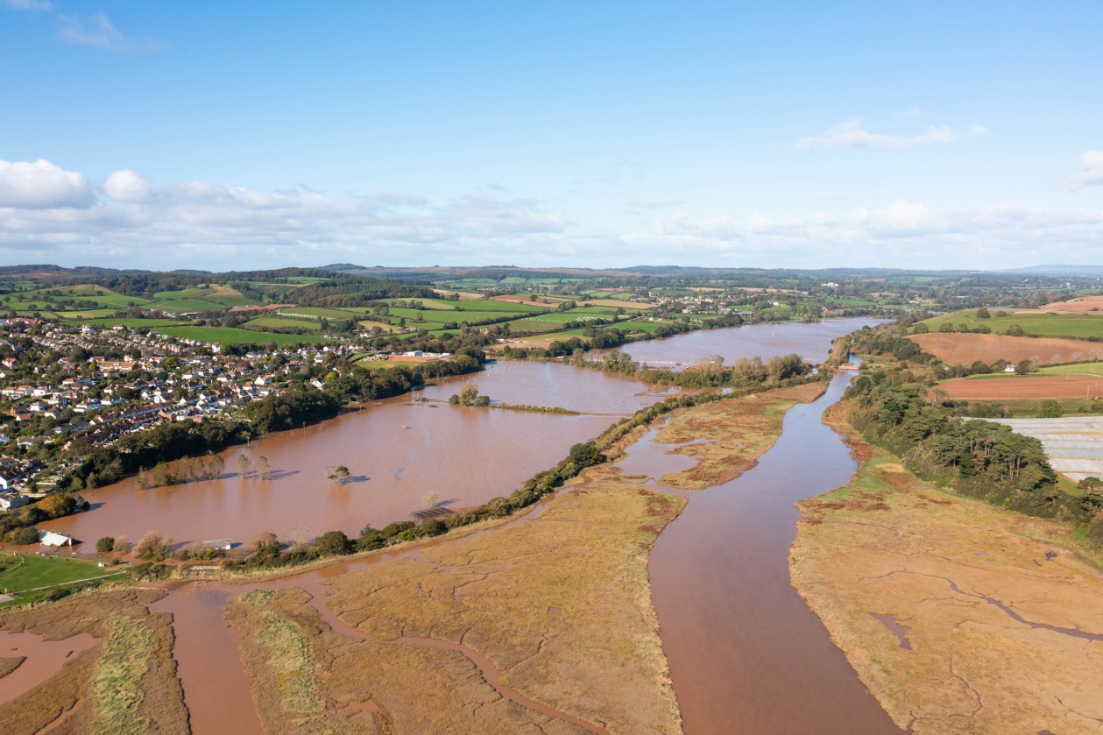
- Study Map A and Photo C.
- Give the four-figure grid reference of Otterton? __________
- Give the six-figure grid reference of the road bridge that crosses the River Otter at Otterton. ____________
- Look at Map A. What is the height above sea level of the floodplain (074824)? ____
- What is the evidence on Map A that the area contained within the embankments has been drained?
----------------------------------------------------------------------------------------------------------------------------------------------------------------------------------------------------------------------------------------------------------------------------------------------------------
- On Map A, locate the minor road (South Farm Road) that crosses the floodplain close to the 83 gridline. This road leads to South Farm, a collection of homes, shops and business units. Using map evidence, suggest why this stretch of road is at risk of flooding.
----------------------------------------------------------------------------------------------------------------------------------------------------------------------------------------------------------------------------------------------------------------------------
- Using Map A, suggest the social and economic impacts when South Farm Road is flooded.
Social impacts | Economic impacts

- Using Map A and Photo D, explain why the Lower Otter is a popular destination for recreation.

Photo D The Otter Estuary Nature Reserve
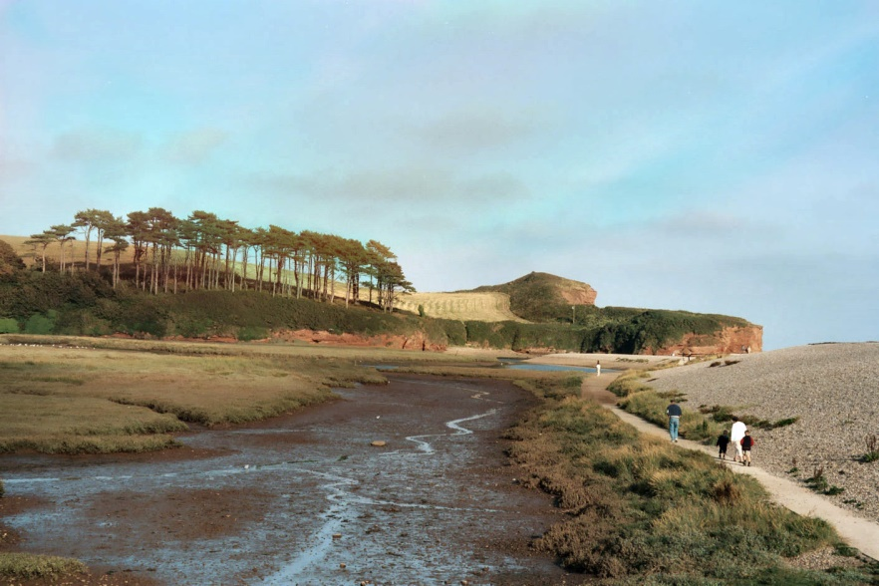

--------------------------------------------------------------------------------------------------------------------------------------------------------------------------------------------------------------------------------------------------------------------------------------------------------------------------------------------------------------------------------------------------------------------------------------------------------------------------------------------------------------------------------------------------------------------------------------------------------------------

Part C: Managed realignment
Following a lengthy consultation process, the agreed long-term sustainable solution to address future climate change (more intense rainfall events leading to river flooding, sea level rise and increased storminess) was managed realignment. This involves the controlled breaching of the embankments to allow water to flood across the entire width of the floodplain. This is happened frequently before the embankments were constructed two hundred years ago.
- Much of the reclaimed farmland will return to natural saltmarsh
- During flood conditions, river water will be able to drain direct to the sea at low tide
- The cricket club will be relocated
- New bridges will be built to safeguard public access along roads and footpaths
The two-year construction project started in 2021. Map E shows some aspects of the project. Photo F shows engineering work at South Farm Road where the road is being raised and a new bridge being constructed. The photo is taken from approximately 069831 (Map A).

Map E The Lower Otter coastal realignment project
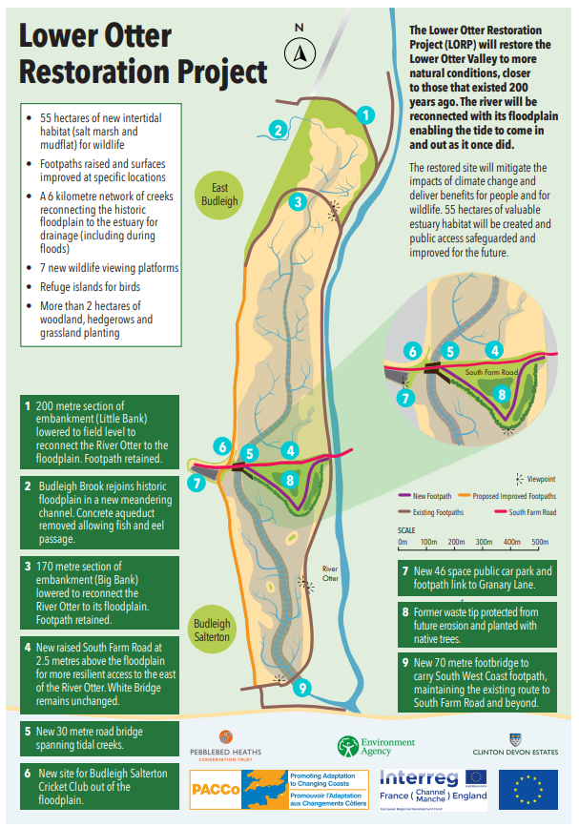

Photo F Engineering work raising South Farm Road and building a new bridge
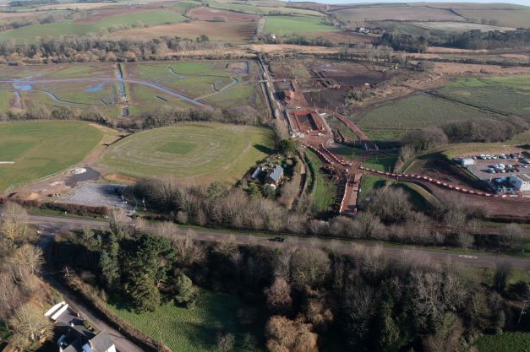

- Look at Map A, Map E and Photo F.
- In what direction is the photo looking? _________
- What is the number of the main road in the photo? __________
- In Photo F, what is the evidence that engineering work is taking place?
------------------------------------------------------------------------------------------------------------------------------------------------------------------------------------------------------------------------------------------------------------------------------------------------------------------------------------------------------------------------------------------------------------------
- On Map A, locate the area of woodland to the south of South Farm Road. What type of woodland is shown? ______________
- Now locate this area on Photo F. Describe the changes to that have taken place to this habitat.
--------------------------------------------------------------------------------------------------------------------------------------------------------------------------------------------------------------------------------------------------------------------------------------------------------------------------------------------------------------------------------------------------------------------------------------------------------------------------------------------------------------------------------------------------------

Map G is an artistic impression showing the Lower Otter in the present day and in the future.
- Using evidence from Map G, suggest how people and wildlife will benefit from the realignment project.
Benefits to people | Benefits to wildlife

- Using Map A, draw a sketch map of the area shown below. (Use the full page grid for this activity)
- Use a pencil to carefully draw the following:
- The 5m contour line either side of the floodplain
- The course of the River Otter
- The main embankments
- The coast (use the high tide line)
- South Farm Road
- The area of coniferous woodland south of South Farm Road
- The saltmarsh
- A selection of straight drainage ditches
- The footpaths (green broken lines)
- Locate and label the following:
- River Otter
- South Farm Road
- South West Coast Path
- Otter Estuary Nature Reserve
- Car park
- English Channel
- Use a double-headed arrow to show the width of the River Otter’s natural floodplain.
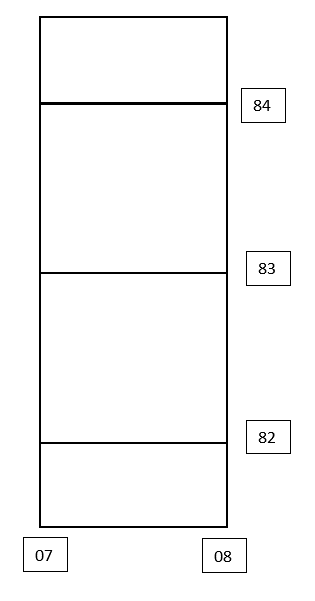
- Use the information in Map E and Map G to add a selection of labels or text boxes to describe the changes associated with the realignment project. Include reference to both people and wildlife.

Sketch map of the Lower River Otter

84

83

82

N
07
08
Scale: 1 km

Map A OS 1:25,000 map of the Lower River Otter
N
I km
'With kind permission and contains Ordnance Survey data'.

