GCSE Managed coastal realignment: Lower River Otter
- The map below shows the course of the River Otter.
- Locate and label the village of Churchinford near the source of the River Otter.
- Draw arrows on the map to identify suitable locations for the three labels written alongside.
- Next to the map write three facts about the River Otter.

1km
The Lower Otter is flat and close to sea level making it vulnerable to flooding from both the river and the sea.
The high drainage density transfers water rapidly into the main river channel increasing the flood risk.
The headwaters of the River Otter are in the Blackdown Hills.
N

- Explain two reasons why the Lower Otter is prone to flooding.
---------------------------------------------------------------------------------------------------------------------------------------------------------------------------------------------------------------------------------------------------------------------------------------------------------------------------------------------------------------------------------------------------------------------------------------------------------------
- Look at Slide 3. What makes the Lower Otter estuary special?
----------------------------------------------------------------------------------------------------------------------------------------------------------------------------------------------------------------------------------------------------------------------------------------------------------

- The photo below is an oblique aerial photo of the Lower Otter.
- Locate and label the following:
- River Otter
- Present day River Otter floodplain
- Budleigh Salterton
- Budleigh Salterton Cricket Club
- Flood embankment
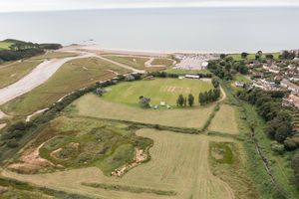
- In which direction is the photo looking?
------------------------------------

- Explain why the embankment was constructed.
--------------------------------------------------------------------------------------------------------------------------------------------------------------------------------------------------------------------------------------------------------------------------------------------------------------------------------------------------------------------------------------------------------------------------------------------------------------------------------------------------------------------------------------------------------------------------------------------------------------------
- Suggest why the embankment in the photo is no longer ‘fit for purpose’.

-------------------------------------------------------------------------------------------------------------------------------------------------------------------------------------------------------------------------------------------------------------------------------------------------------------------------------------------------------------------------------------------------------------------------------------------------------------------------------------------------------------------------------------------------------------------------------------------------------------------------------------------------------------------------------------------------------------------------------------------------------------------------

- The photo below shows river flooding of the Lower Otter in 2018. The photo is looking north.
- Locate and label
- the River Otter
- the embankment
- the cricket ground (underwater)
- saltmarsh

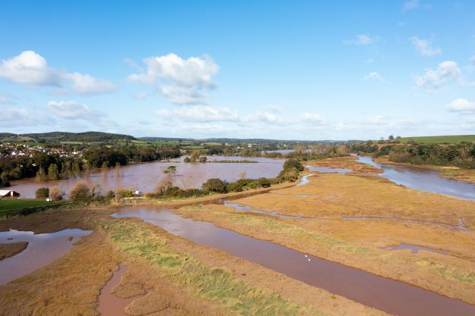
- Explain why the embankment contributed to the extent of the flooding shown in the photo.
----------------------------------------------------------------------------------------------------------------------------------------------------------------------------------------------------------------------------------------------------------------------------------------------------------
- Outline the effects of river flooding in 2018 and 2021 on people and on the flood embankments.
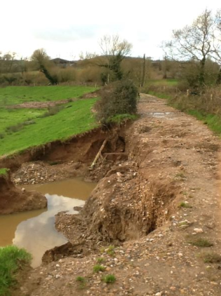
------------------------------------------------------------------------------------------------------------------------------------------------------------------------------------------------------------------------------------------------------------------------------------------------------------------------------------------------------------------------------------------------------------------------------------------------------------------------------------------------------------------------------------------------------------------------------------------------------------------------------------------------------------------------------------------------------

- Draw simple sketches to show the three coastal management options for the Lower Otter.
- Do nothing

- Hold the line

- Managed realignment

- Describe the three main reasons why the preferred option was ‘managed realignment’.

- Use the information on Slides 14 and 15 to write labelled annotations describing the main features of the managed realignment plan.

- The total cost of the scheme is £12m. £8.5m will come from the European Interreg France (Channel) England Programme. Calculate this as a percentage of the total cost.

- Describe the works associated with the managed realignment plan (Slide 16).
2021 2022 2023

- The map below shows a selection of works carried out as part of the Lower Otter managed realignment project. Use highlight pens or colours pencils to shade each label, categorising the works into three groups:
Flood protection

Improved amenity (benefiting people)

Environmental (benefiting wildlife)

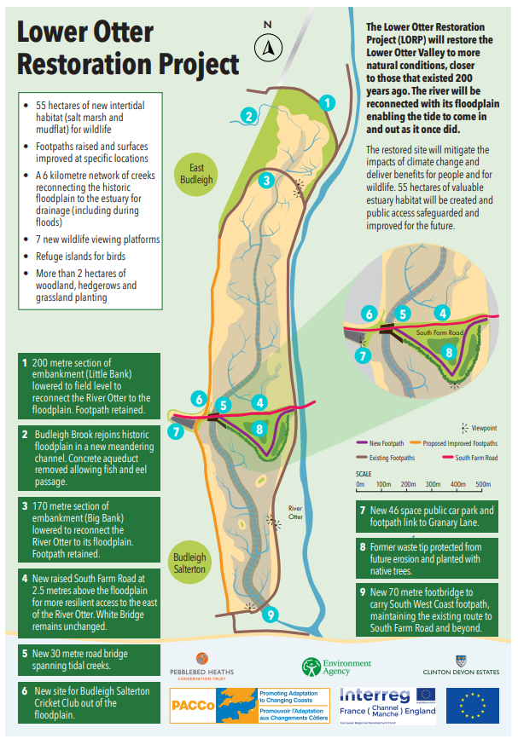

- The photo graph is a view across the River Otter floodplain looking towards the south-east. The artist sketch below visualises the scene in 2038.
- On the artist sketch, locate and label:
    - Saltmarsh and mudflats
    - Footbridge carrying the South West Coast Path
Cricket Club
    - Flocks of birds

- Describe the changes in the landscape between the present day and 2038.
----------------------------------------------------------------------------------------------------------------------------------------------------------------------------------------------------------------------------------------------------------------------------------------------------------------------------------------------------------------------------------------------------------------------------------------------------------------------------------------------------------------------------------------------------------------------------------------------------------------------------------------------------------------------------------------------------------------------------------------------------------------------------------------------------------------------------------------------------------------------------------------------------------------------------------------------------------------------------------------------------------------------------------------------------------------------------------------------------------------------------------------------------------------------------------------------------------------------------------------
- Community involvement has been at the heart of the project’s development. There have been a series of exhibitions, consultations and stakeholder group meetings enabling concerns to be raised and addressed.

Read the two newspaper extracts below which identify some of the concerns of local people. Use a highlight pen to identify the main concerns raised by the residents.
Budleigh Salterton residents facing the prospect of a cycle track being built behind their homes are hopeful their concerns will be listened to after planners agreed to meet them
The proposal to upgrade a path to allow cycling to the east of Granary Lane has been suggested by landowner Clinton Devon Estates (CDE) and the Environment Agency, which are working together on the Lower Otter Restoration Project, which suggests reintroducing tidal flooding to the Otter to prevent flooding of homes and businesses.
Residents said they were shocked to only find out about the proposals in May, with concerns about noise from cyclists, and the risk of tree branches from their properties falling on the path.
Resident David Butler said: “There is a broad spectrum of residents in Granary Lane. Some people think all change is bad, but CDE (Clinton Devon Estates) and other authorities are trying to deal with a problem.”
David said that while some cyclists were in favour of a cycle path, some residents had concerns about the noise.
Exmouth Journal 6 July 2015
https://www.exmouthjournal.co.uk/news/meeting-to-discuss-cycle-path-5736610

Writing to the Journal, readers Lynne and Ian Wycherley have raised concerns about the landfill.
They say there is a risk of ‘tidal leaching of the highly toxic landfill’, as ‘many highly toxic substances were dumped liberally in the landfill at the heart of this scheme’.
In response, project manager Mike Williams said: “The Lower Otter Restoration Project has the potential to deliver significant environmental benefits, dealing with a legacy of problems and enabling more sustainable management of the lower Otter valley.
“The former landfill site is currently an unprotected liability that would be at risk if the embankments failed accidentally. “There is little real information on what materials were deposited at the site.
Exmouth Journal 30 November 2015
https://www.exmouthjournal.co.uk/news/river-otter-plan-low-risk-of-pollution-5743386

- Having identified some of the concerns raised by local people in 2015, read the following statement from the Lower Otter Restoration Project outlining how the project has addressed these concerns.

The cycle path
The creation of a cycle path is not one of the aims of the Lower Otter Restoration Project. This idea was initially put forward by a member of the public at a previous public consultation event, as an additional community benefit that the project could bring. Other consultation responses have also been in favour of a new cycle path. However, as local residents have significant concerns about the noise levels a cycle route might bring and the local authority has not been strongly in favour we don't intend to pursue this potential added benefit as part of the project.
The tip
Based on the findings of site investigations completed by a specialist contractor (and detailed in a report in 2017) there is no evidence of any toxic materials currently leaching from the site into the surrounding environment. These investigations included the digging of test pits across the tip and the examination of their contents and the monitoring of ground water quality. As part of the project, part of the western section of the landfill will be removed. The sides of the remainder of the disused landfill will be protected by a combination of rock revetment, erosion protection matting and extended side slopes depending on the speed of flow in each area. The scheme will also improve the capping of the site. As a result of this additional protection after the scheme we believe the tip will be less of an environmental liability than at present.

To what extent will the benefits of the Lower Otter managed realignment project outweigh the costs?
--------------------------------------------------------------------------------------------------------------------------------------------------------------------------------------------------------------------------------------------------------------------------------------------------------------------------------------------------------------------------------------------------------------------------------------------------------------------------------------------------------------------------------------------------------------------------------------------------------------------------------------------------------------------------------------------------------------------------------------------------------------------------------------------------------------------------------------------------------------------------------------------------------------------------------------------------------------------------------------------------------------------------------------------------------------------------------------------------------------------------------------------------------------------------------------------------------------------------------------------------------------------------------------------------------------------------------------------------------------------------------------------------------------------------------------------------------------------------------------------------------------------------------------------------

